**電通二甲微處理器實驗 實驗結報**

|  |  |  |  |
| --- | --- | --- | --- |
| **實驗名稱** | LED Blink | | |
| **組別** | 27 | **組員** | 04050015陳姿華、04052502許書瑜 |

1. **實驗目的**

* 使用circuits.io模擬Arduino UNO電路及程式
* 繪製電路圖
* 觀察Arduino UNO之輸出
* 學習將程式碼及實驗報告上傳至Github

1. **實驗步驟**

(1)填寫分組表單

(2)啟動Arduino IDE,載入Blink程式碼

(3)至circuits.io註冊帳號，啟動Arduino模擬器

(4) 接上LED電路

(5)修改程式，將LED輸出改為Pin9

(6) 觀察LED之閃爍間隔

(7)修改程式 ,使LED閃爍間隔分別增加為2倍及1/2倍,

重新量測並截圖

(8)畫出電路圖

1. **程式碼**

**(1)「LED閃爍」程式 ---> 1000ms(1秒)、Pin13**

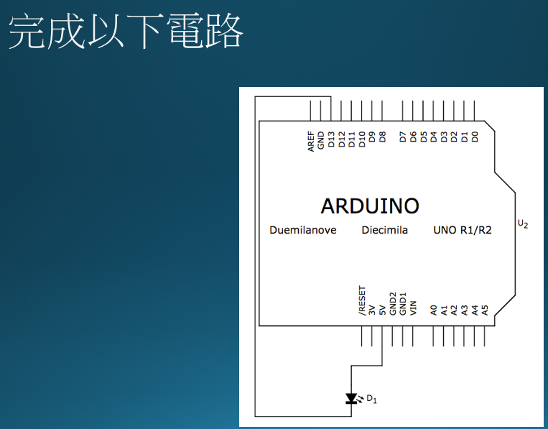

/*

Blink

Turns on an LED on for one second, then off for one second, repeatedly.

Most Arduinos have an on-board LED you can control. On the Uno and

Leonardo, it is attached to digital pin 13. If you're unsure what

pin the on-board LED is connected to on your Arduino model, check

the documentation at http://arduino.cc

This example code is in the public domain.

modified 8 May 2014

by Scott Fitzgerald

*/

// the setup function runs once when you press reset or power the board

void setup() {

// initialize digital pin 13 as an output.

pinMode(13, OUTPUT);

}

// the loop function runs over and over again forever

void loop() {

digitalWrite(13, HIGH); // turn the LED on (HIGH is the voltage level)

delay(1000); // wait for a second

digitalWrite(13, LOW); // turn the LED off by making the voltageLOW

delay(1000); // wait for a second

}

**(2)**

* **更改 delay 時間為 500 / 2000 ms, 觀察輸出結果**
* **更改電路圖及程式中 LED 腳位改為 pin9, 觀察輸出結果**

/*

Blink

Turns on an LED on for one second, then off for one second, repeatedly.

Most Arduinos have an on-board LED you can control. On the Uno and

Leonardo, it is attached to digital pin 13. If you're unsure what

pin the on-board LED is connected to on your Arduino model, check

the documentation at http://arduino.cc

This example code is in the public domain.

modified 8 May 2014

by Scott Fitzgerald

*/

// the setup function runs once when you press reset or power the board

void setup() {

// initialize digital pin 13 as an output.

pinMode(9, OUTPUT);

}

// the loop function runs over and over again forever

void loop() {

digitalWrite(9, HIGH); // turn the LED on (HIGH is the voltage level) delay(2000); // wait for two seconds

digitalWrite(9, LOW); // turn the LED off by making the voltageLOW

delay(2000); // wait for two seconds

}

1. **實驗結果及分析**

(1)第一個程式中的LED燈接到5V和Pin13，因為delay 1000ms所以LED燈每1秒閃爍1次。

(2)第二個程式中的LED燈接到5V和Pin9，因為delay 2000ms 所以LED燈每2秒閃爍1次。

1. **心得討論**

這一次的實驗我們利用Arduino的模擬器進行初步的練習，對模擬器的使用也有了初步的了解，藉由這次基礎的程式碼我們能夠完全理解程式當中所描述的內容，也藉由老師課堂當中的說明我們更加清楚Arduino的功能以及用途，Arduino真的是個便宜、不占空間又方便利用的好東西。

1. **修改電路圖**
   1. **1000ms 13Pin**

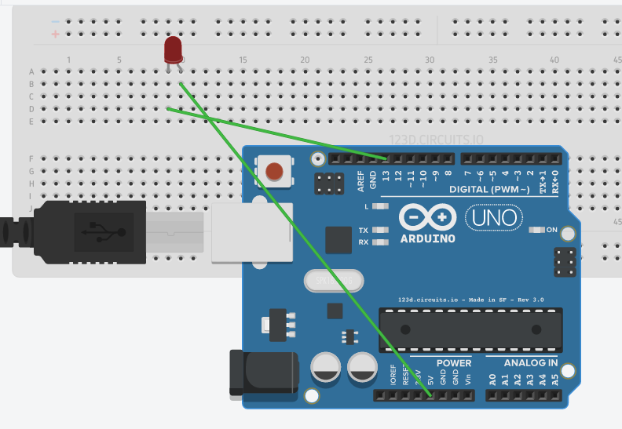

* 1. **2000ms 9Pin**

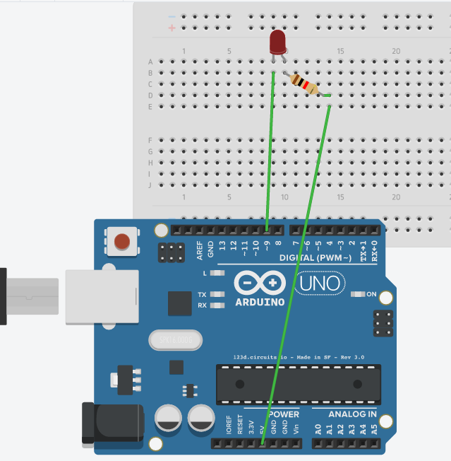

**7.修正程式碼**

這次的實驗室跑原有的內建程式，進行更改練習。